Request for Proposal (RFP)
Development of PMS Electronic system
Helvetas Kosovo invites interested companies to provide services as described below.
- Contract description
The overall goal of DEMOS is to support Kosovo in its transition process towards a democratic, decentralised state in which municipalities exercise socially inclusive governance and provide effective services responding to citizens’ priorities and needs.
The required services are annexed in this document.
- Timetable
 | DATE | TIME - CET
Tender announcement | From 05.06 -06.06.2020 | -
Deadline to request the tender dossier | 02.07.2020
Deadline for written enquiries | 18.06.2020 | 16:00
Last date for Helvetas Kosovo to issue clarifications | 22.06.2020 | 16:00
Deadline for submitting offers | 02.07.2020 | 14:00
- Nature of the contract
Service Contract
- Negotiations
Helvetas Kosovo reserves the right to enter into negotiations with all or part of eligible bidders in order to amend and/or complete their original offers.
Negotiations may concern the technical, financial, legal and other aspects of the contract.
- Eligibility
Participation is open to all companies, registered in the Republic of Kosovo.
All eligible entities or groupings of such entities (consortia) may apply.
A consortium may be a permanent, legally-established grouping or a grouping which has been constituted informally for a specific tender procedure. All members of a consortium (i.e. the leader and all other members) are liable to Helvetas Kosovo, while the leader takes the lead responsibility.
- Costs for preparing offers
No costs incurred by the bidder in preparing and submitting the offers are reimbursable. Such costs fall under the responsibility of the bidder, including the costs incurred during negotiating and interviewing process.
- Sub-contracting
Sub-contracting services to another legal person is not allowed.
- Provisional commencement date of the contract
July 2020
- Initial period of execution and possible extension of the contract
Services are to be provided between July 2020 –December 2021
- Evaluation of offers
Each offer will be evaluated in accordance with the criteria and the weighting as detailed below. In the case of offers submitted by a consortium, these criteria will be applied to the consortium as a whole. The criteria for evaluation of goods/services or works will be examined in accordance with the requirements indicated in attachments.
The entire evaluation procedure is confidential. The Purchasing Panel (PP) decisions are collective and its deliberations are held in closed session. The members of the PP are bound to secrecy. The evaluation reports and written records are for official use only and may be communicated neither to the bidders nor to any party other than Helvetas Kosovo.
  - Eligibility criteria
Requirements | Documentary evidence
- Application form | Signed application form
- The bidder is registered in Kosovo | The full Registration certificate
- VAT number | VAT certificate
- Fiscal number | Fiscal number certificate
- The total turnover of the company/organisation over the past 3 years (2017,2018 and 2019) must be equal to or exceed € 120.000 | Financial statements (documentary evidence) or Annual Tax Statements on income tax (TAK)
- The bidder has no open case of a dispute, an execution procedure, reorganisation, bankruptcy or insolvency procedure | The bidder must submit a written statement under oath. At the earliest possible moment, the bidder must submit a valid proof issued by a competent judicial or administrative authority – in hard copy.
- All taxes paid | A valid tax administration certificate or a valid agreement signed with the Tax Administration of Kosovo to repay the outstanding debts
- Key Personnel | CV(s)( with documentary evidence)- Part 1-Term of References (ToR)
- The bidder has carried out in the course of the past 5 years(2015,2016,2017,2018,2019) at least 2 projects in fields specified in section Part 1 above. | A list of projects according to template in PART 1 – Application package under Professional Capacity section, accompanied by documentary evidence for at least 2 projects relevant to the requirements of this tender. By documentary evidence, this refers to contracts, references or other documentary evidence issued by a contracting authority. Only documentary evidence found to be relevant for the tender’s thematic fields will be considered.

The bidders that pass the eligibility criteria will be processed for further evaluation.
11.2 Evaluation criteria of eligible offers
Criteria for evaluation of the Technical offer
Requirements | Documentary evidence
1. Key Personnel | CV(s)( with documentary evidence)
2. The bidder has carried out in the course of the past 5 years (2015,2016,2017,2018,2019) at least 2 projects in fields specified in section Part 1 above. | A list of projects according to template in PART 1 – Application package under Professional Capacity section, accompanied by documentary evidence for at least 2 projects relevant to the requirements of this tender. By documentary evidence, this refers to contracts, references or other documentary evidence issued by a contracting authority. Only documentary evidence found to be relevant for the tender’s thematic fields will be considered.
The bidders that pass the Technical evaluation (min 50% of technical evaluation scoring) will be processed for further evaluation.
Criteria for evaluation of the financial offer:
Requirements | Documentary evidence
Financial offer provided by supplier ( Part 2) | Financial offer in EUR
The weighting of the criteria for evaluation of technical and financial offers are as follows:
Criteria | Max points
Technical offer* | 50
Team leader | 10
1 Key experts - Software Developer | 6
2 Key experts - Software Developer | 4
Previous bidder experience/capacity | 5
Methodology | 25
Financial offer – Total cost (sum of units) | 50
Total maximum score | 100
*Evaluation of the offers will be done progressively, namely lower quality of elements of the technical offer and higher financial offer will receive less points from the maximum points presented in the table.
After evaluation of offers, Helvetas Kosovo reserves the right to enter into negotiations with all or part of eligible bidders in order to amend and/or complete their original offers.
Contract will be awarded to the economically most advantageous offer. The economically most advantageous offer is established by weighing technical quality against price on a 50/50 basis. Helvetas Kosovo reserves the right to contract only part of required services or cancel this tender procedure should it not be satisfied with the quality of offers.
- Submission of offers
The offer must contain 1 original, clearly marked ‘Original’, and 3 copies, each marked ‘Copy’.
Offers must be submitted using the standard forms provided by the Helvetas Kosovo (PART 1 and PART 2), in hard copy format only. Offers must be submitted using the double envelope system: the outer parcel or envelope shall be marked as “Development of PMS Electronic system, Ref: HSI-020720 D. This shall contain two separate, sealed envelopes, one bearing the words ‘Envelope A’ and the other ‘Envelope B’.
Envelope A shall contain PART 1 – Application Package including documentary evidence in the following order:
- Eligibility documents
- Application form
Bidders have to supply signed Application form. The Application form should be accompanied by the following documentation for the bidder (and for each consortium member, if applying as a consortium):
- Full registration certificate
- VAT number
- Fiscal number
As part of the eligibility documents, bidders have to supply Economic, financial and professional capacity form, accompanied by the following documentation for the bidder (and for each consortium member, if applying as a consortium):
- Financial statements
- The bidder must submit a written statement under oath. At the earliest possible moment, the bidder must submit a valid proof issued by a competent judicial or administrative authority – in hard copy
- A valid tax administration certificate or a valid agreement signed with the Tax Administration of Kosovo to repay the outstanding debts
- Documentary evidence for at least 2 projects relevant to the thematic fields of this tender (if applying as a consortium, for all consortium members together)
- Technical offer form
Bidders have to supply the Technical offer form, accompanied by the following documentation for the bidder (Core team):
- Team leader
- 1 Key experts - Software Developer
- 2 Key experts - Software Developer
- Previous bidder experience/capacity
- Methodology

Envelope B shall contain PART 2 - Financial offer.

The Financial offer must be presented in Euros. The fees proposed in this offer should be all inclusive; the supplier/contractor will cover all costs to perform their tasks (e.g. office accommodation, transport, internet access and equipment, administrative and secretarial support, interpretation etc.). Helvetas Kosovo is exempt from VAT, thus the fees offered should be without VAT.
Offers must be submitted in English language exclusively to the following address:
Ref: HSI - 020720 D
HELVETAS Swiss Intercooperation - Kosovo
Str: Nazim Gafurri 33, P.O. Box 2
10000, Prishtina.
Republic of Kosovo
Applications submitted after the deadline will not be considered.
- Alteration or withdrawal of applications
Candidates may alter or withdraw their offers by written notification prior to the deadline for submission of tenders. No offer may be altered after this deadline.
Helvetas Kosovo retains ownership of all offers, which have not been withdrawn. Consequently, bidders do not have the right to have their offers returned to them.
- Validity of offers
Bidders are bound by their tenders for 90 days after the deadline for submitting offers. In exceptional cases, before the period of validity expires, Helvetas Kosovo may ask bidders to extend the period of validity for a specific number of days, which may not exceed 40.
- Signature of the contract(s)
Within 10 days of receipt of the contract already signed by the Helvetas Kosovo, the selected bidder shall sign and date the contract. Failure of the selected bidder to comply with this requirement may constitute grounds for annulling the decision to award the contract. In this event, Helvetas Kosovo may award the tender to another bidder or cancel the tender procedure.
- Terms of payments
Helvetas Kosovo is not a payer of value added tax (VAT). Prices in the application must be submitted, taking into account all expenses.
The payment will be made via bank account transfer to the winner of the tender in EUR within a maximum of 30 working days from the date of acceptance of goods or execution of services or works. Cases of non-performance of obligation and their legal consequences will be separately indicated in the contract.

- Terms of cooperation
In the case of a contracting, the parties will have to perform according to the established time and in accordance with Helvetas Kosovo – Supplier purchase order or Helvetas Kosovo – Service provider contract. Helvetas Kosovo has the right to increase or decrease the number of ordered items. Helvetas Kosovo has the right to choose a supplier/ implementer on the given offer according to its own discretion. Helvetas Kosovo has the right to re-formulate the Request for proposal (RFP) to its own discretion, if any additional items are needed. In case of failure or non-compliance with contractual obligations, Helvetas Kosovo has a unilateral right to terminate the contract without incurring any legal obligation.
The Applicant has to be familiar with all instructions, forms and requirements mentioned in the RFP, documents. The responsibility for the submission of the offer in accordance to these requirements lies entirely with the Applicant.
Helvetas Kosovo signs a purchase order/contract with the winning bidder. The contract will come into force upon signature by both parties.
- Ethics clauses/Corruptive practices
Bidders making false declarations may be subject to financial penalties representing 10% of the total value of the purchase order/contract being awarded. This rate may be increased to 20% in the event of a repeated offence.
Any attempt by a company to obtain confidential information, enter into unlawful agreements with competitors or influence the PP or the Helvetas Kosovo during the process of examining, clarifying, evaluating and comparing offers will lead to the rejection of its offer and may result in penalties as described above.
Companies must not be affected by any conflict of interest with other bidders or parties involved in the project. Helvetas Kosovo reserves the right to suspend or cancel the RFP procedure and contract if corrupt practices of any kind are discovered at any stage of the award process or during the execution of a contract.
Companies will be rejected or contracts terminated if it emerges that the award or execution of a contract has given rise to unusual commercial expenses. Such unusual commercial expenses are commissions not mentioned in the main contract or not stemming from a properly concluded contract referring to the main contract, commissions not paid in return for any actual and legitimate service, commissions remitted to a tax haven, commissions paid to a payee who is not clearly identified or commissions paid to a company/organisation which has every appearance of being a front company.
Contractors found to have paid unusual commercial expenses related to this project are liable, depending on the seriousness of the facts observed, to have their contracts terminated and/or be penalised.
The Helvetas Kosovo reserves the right to suspend or cancel the procedure, where the award procedure proves to have been subject to substantial errors, irregularities or fraud. If substantial errors, irregularities or fraud are discovered after the award of the purchase order/ contract, the Helvetas Kosovo may refrain from concluding the purchase order/contract and/or terminate the purchase order/ contract.

- Operational language
All written communications for this tender procedure and contract must be in English.

Additional information

The conclusion of the tender and the award of contract are subject to the availability of funds.
Helvetas Kosovo reserves the right to annul this tender procedure at any time, without any liability
on its side.

PART 1 – APPLICATION PACKAGE

APPLICATION FORM

1 SUBMITTED by (i.e. the identity of the bidder)
 | Name(s) of entity(ies) making this application | Nationality
Leader
Member 2
Member 3 ...

2 CONTACT PERSON (for this application)
Name
Organisation
Address
Telephone
e-mail

3 STATEMENT
I, the undersigned, the authorized signatory of the above bidder (for consortiums, every consortium member should sign a separate statement as part of this application), hereby declare that we have examined the tender dossier for the contract referred to above. We hereby accept its provisions in their entirety, without reservation or restriction.
We agree to become one of the parties of the framework contract and to submit an offer whenever requested by the Helvetas Kosovo in accordance with the terms of the tender dossier and the conditions laid down, without reservation or restriction.
We are making this application for this tender in our own right. We confirm that we are not tendering for the same contract in any other form. We understand that our consultants may be excluded if we propose consultants who have been involved in offers of other bidders.
We are fully aware that, for consortiums, the composition of the consortium cannot be changed in the course of the tender procedure, unless Helvetas Kosovo has given its prior approval in writing. We are also aware that the consortium members have joint and several liabilities towards Helvetas Kosovo

concerning participation in the above tender procedure and any contract awarded to us as a result of it.
We will inform Helvetas Kosovo immediately if there is any change in the above circumstances at any stage during the implementation of the contract. We also fully recognize and accept that any inaccurate or incomplete information deliberately provided in this application may result in our exclusion from this and other contracts funded and/or managed by Helvetas Kosovo and that penalties may be applied as specified in the tender dossier.
We note that the Helvetas Kosovo is not bound to proceed with this tender and that it reserves the right to award only part of the contract and that it will incur no liability towards us should it do so.
Signed on behalf of the bidder

Name
Signature
Date

ECONOMIC, FINANCIAL AND PROFESSIONAL CAPACITY

1. ECONOMIC AND FINANCIAL CAPACITY
Financial data for the consortium as a whole | 2017  € | 2018  € | 2019  € | Average  € | This year  €
Average annual turnover
Balance sheet

Financial data for member of consortium __________ | 2017  € | 2018  € | 2019  € | Average  € | This year  €
Average annual turnover
Balance sheet
2. PROFESSIONAL CAPACITY
Ref no (max 10) | Project title
Name of legal person | Country | Overall contract value (EUR) | Proportion carried out by legal person (%) | In case of Services (No of staff provided) | Name of client  and phone/e-mail | Origin of funding | Dates (start/end) | Name of consortium members, if any
… | … | … | … | … | … | … | … | …
Detailed description of project |  |  |  |  |  | Type and scope of services provided
… |  |  |  |  |  | …

TECHNICAL OFFER
- EXPERIENCE

Experience of the bidder will be provided as part of Economic, financial and professional capacity above.
- STAFF
Manpower | Women | Men | Minorities | Persons with disabilities
Permanent full-time staff
Other staff

Term of Reference (ToR) for

Development of PMS Electronic system
Background
The overall goal of Decentralisation and Municipal Support project, phase II (DEMOS II), is to support Kosovo in its transition process towards a democratic, decentralised state in which municipalities exercise socially inclusive governance and provide effective services responding to citizens’ priorities and needs. The main components of the DEMOS programme are:
- Municipalities exercise improved democratic governance for the benefit of the people through decision-making processes, which are transparent, participative and inclusive of marginalised groups and through sound human and financial management practices.
- The policy framework is more conducive for decentralised local governance and better implemented.
The central part of the project is the Municipal Performance Grant (MPG) for municipalities. This is an incentive scheme, co-financed by the Kosovo, Swiss, Sweden and Norway governments, with a focus on good and democratic local governance. Municipal performance is assessed on annual basis and the grant is distributed according to the performance score.
The Performance Management System (PMS) of the Ministry of Local Governance Administration (MLGA) is used as the main data source for the MPG. PMS is under revision and it measures the performance of municipalities in 19 fields.
MLGA has developed, with the support of DEMOS, the electronic system of the Performance Management System (PMS-ES). Trainings were provided to MLGA staff and municipal officials to use the PMS-ES. After trainings were completed, the system has been tested during. During this phase, some deficiencies in the functioning of the system have been identified. For deeper and better analyse the operation of the PMS-ES and to identify all deficiencies, DEMOS hired an expert. The expert provided his recommendation to DEMOS and MLGA, and will be used as guides for upgrading the system.
Parallel to this, MLGA and DEMOS have worked together to further upgrade PMS. This work resulted in adding new fields and indicators but also revising some of the existing ones. These changes have to be also reflected in the PMS-ES.
Objectives
The objective of this assignment is to:
- Development the PMS-ES:
  - As base will be the old system, with the possibility for a new design of the application using the latest technology, for example Microsoft development frameworks ASP.Net MVC or ASP.Net Core MVC
  - The database should be designed for SQL SERVER;
  - The application will ensure not to have previous deficiencies
  - Fix identified deficiencies
  - Accommodate recent requirements to the PMS, as explained below
  - Develop and integrate the Municipal Performance Grant Module
- Support implementation of the upgraded PMS-ES
- Provide all necessary support and training for a smooth implementation of the PMS – ES:

PROFILE OF CONSULTANTS
The following consultants are required to be included in the proposals for this invitation:
3 CV(s) to be submitted

Team leader
Qualifications and skills
- Bachelor, preferably Master, degree in Computer Engineering, or similar fields
- Training Certifications in the field of programming (Microsoft Certified Solution Developer, PHP or similar)
Experience
- At least 10 years of experience in managing similar projects
- Experience developing web applications in the platform proposed for this project
- Experience developing web sites
- Experience working with PHP, MySQL and/or Microsoft SQL Server or other platforms proposed for this project
- Experience developing web services and application programming interfaces (APIs)
Team Leader will be responsible for the project implementation, including but not limited to developing work plans, organising daily activities, monitoring and evaluation, reporting, etc.

Key-expert 1: Software Developer
Qualifications and skills
- Bachelor, preferably Master degree in Computer Engineering, or similar fields
Experience
- At least 8 years of experience with similar projects
- Experience developing web applications in the platform proposed for this project
- Experience developing web sites
- Experience working with PHP, MySQL and/or Microsoft SQL Server or other platforms proposed for this project
- Experience developing web services and application programming interfaces

Key-expert 2: Software Developer
Qualifications and skills
- Bachelor, preferably Master, degree in Computer Engineering, or similar fields
Experience
- At least 5 years of experience with similar projects
- Experience developing web applications in the platform proposed for this project
- Experience developing web sites
- Experience working with PHP, MySQL and/or Microsoft SQL Server or other platforms proposed for this project
- Experience developing web services and application programming interfaces

Tasks and Activities of the consultant(s)

Development
The following section describes the requirements for the bug fixes, and upgrades to the system.

System operating
The system should be developed according to the specifics required by the ministry, in accordance with the constituent elements of the Municipal Performance Management System. The possibility of complete remodeling of operations within the system in terms of: redefining the content of areas, results, indicators, roles of users according to the approaches allowed by the ministry, as well as flexibility in the construction of units of measurement is not excluded.

New platform design
The development of the system should be done in accordance with the preferences of the ministry regarding the selection of the design version (system visualization).

Bug Fixing
All errors on the system shall be fixed to ensure the normal operation of the current version. Refer to the expert’s findings report and fix all reported errors in the modules of the PMS. This will ensure current version to work as expected.

Data Validations
In accordance with MLGA and the PMS Main document all the forms shall be validated to ensure that the inputs are validated against the expected data/data type/value.

Adding New Areas
Based on the latest regulation a new set of Areas of performance shall be included in the system. MLGA will provide such a regulation as per request. Currently the requirements are for four (4) new areas to be included. Adding new area should be offered by an interface allowing users to add or update existing areas.

Adding New Pointers/Indicators
System shall allow adding new indicators with the formula through a configurable module from MLGA. These indicators will be added for new Areas as described in the above section. Adding new indicators should be allowed through user interface.

Adding New Users
System shall allow adding new users by searching into Active Directory and giving it a role on the system, this should be done through System Administrators’ role.

Submitting of performance reports (additional functionality)
For every report submitted there should exist possibility to add a document or link of the document during submission of the reports.

Time Schedule for Submission of the Reports by Municipalities
A module should be developed to allow MLGA officials to specify the deadline for submission of performance reports by municipalities. An example of how this module would look like is provided in the following figure.
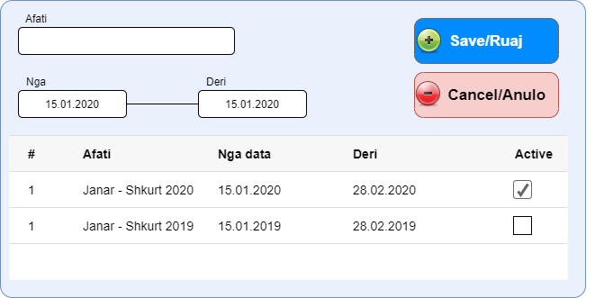

Module for Pointer/Indicator Comparison
In order to do comparisons system shall allow for selecting one or more pointers to be display for comparison between multiple municipalities, to compare the performance on particular indicator/s.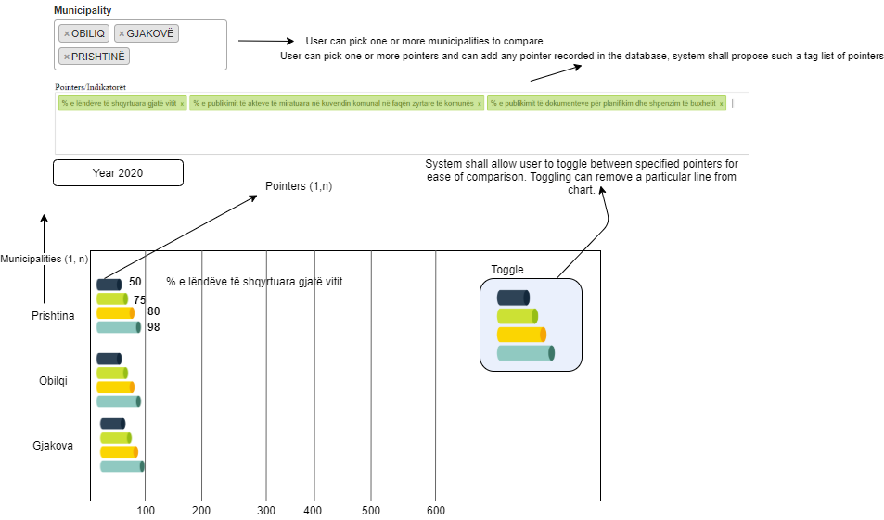

As depicted in the above figure, the user shall pick one or more municipalities, and one or more indicators for comparison, also a year of performance reporting should be chosen. Municipalities shall be displayed in Y axis, together with each pointer showing the amount of values per pointer. As depicted indicators shall display together with their values, also a description of the indicators for easy comparison.

Statistical and Graphical Data Reports
System shall allow generation of reports based on the Municipality, Areas, and Indicators and generate graphical charts and tabular data. Tabular data shall be exportable to Word, Excel, PDF, and graphical charts on any of the following formats: PNG, JPG, or BMP.

New search module (filters)
Complete review of research functions within the system. The system should include numerous research options that enable classification of data, according to: fields, indicators, results, data. Filters should enable data grouping based on the elements defined above, referring to time limits without limit, based on municipalities, or other elements required by the ministry. The system should allow the processing of required data by enabling their export to formats: excel, word, PDF, or any other form. The system must also allow their graphical presentation, immediately in the required format during system development.

Comparative module
The system should allow comparison functions of the performance between municipalities according to free selection and without restrictions. Comparisons should provide data on the performance of two or more municipalities, according to the authorized selection. The system allows levels of comparison between municipalities according to performance areas, results, indicators or relevant data. The values obtained during the comparison should produce statistical reports, presented automatically in graphic, tabular or other required forms.

Design and integrate a dashboard
System should include a fully featured dashboard that will be used to display different information based on the Municipality, Areas, and Indicators. The dashboard is meant to present the data for public and include interactivity elements so that interested parties may compare and analyse data across years, municipalities, indicators, etc. Further information will be provided during development stage.

Yearly performance of municipalities
A module where users would be able to see the trends of performance yearly, and compare the results with the past years.
The trending report and chart shall allow users to:
- Generate municipality performance based on Areas, Indicators and display them in yearly manner where most performative municipality would reach the top of the results. This will be used for Municipality rankings.
- Generate charts and reports based on the performance on particular area, or indicator. For example, we select a particular indicator, and a chart is displayed showing the trends yearly.
- Performance by area, showing one or more selected areas on one or more municipalities (or all areas, and all municipalities) in a yearly trending chart.
- Ranking of municipalities based on high, medium and low performance, based on areas/indicator/results, on a graphical chart and tabular data.
The reporting modules shall allow users to see all reports, for MLGA the access should be granted to all municipalities, and for the municipal level users it should be limited to their municipality.

GUI Service
Developer should program an interface for open data, where users would be allowed to perform comparative data on areas and/or indicators, or extract statistical. GUI Service should be programmed in such a way that it is easy integrated into any web site through <iframe>. Available group of data before integration should be consulted with MLGA and the schedule of such a publishing.

Testing
System should be fully tested before deployment, for each module a test should be performed and documented.
There shall be two stages of the software testing and acceptance:
- Factory Acceptance Testing (FAT)
- User Test (UT)

Municipality performance module
Each year a performance measurements are run on each municipality to see their performance and evaluate them against the criterion for municipal investments, the following module describes the needs for such a module. This module shall extract all required information from PMS database and shall save last session’s data of the user and shall be designed according to the MPG relevant documents.
The following figure depicts an example of how the module would look like.
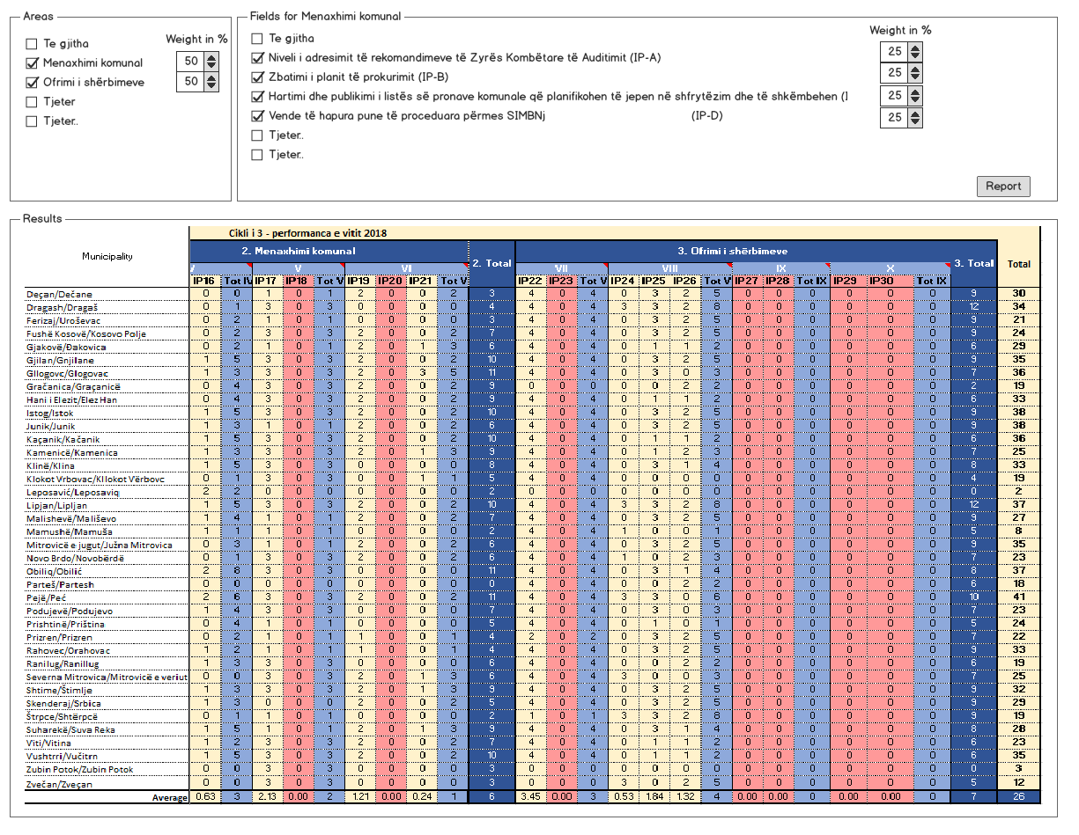
As can be seen in the above figure, a user is supposed to select one or more Areas of interest and for each area he/she is going to select a set of one or more fields of interest for particular area.
The calculation is made on weights of % in overall process that is specified in the beginning.
For example, in the figure there are two (2) areas selected and are given a 50% for each, but this might have been set differently giving for example for Area of “Municipal management” 30% and for other one 70%, or there might as well be more than two (2) areas selected and each of them have a piece of overall weight of %, which shall not exceed 100% in the end.
Same happens when you select one or more Fields, but by default an average should be given to each indicator, say there might have been four (4) fields/indicatorsselected, a default of 25% per each should be applied, allowing the user after that to be able to change such a value in accordance to make an overall 100%, which is then calculated using the formula:
$$Area Performance=\frac{Calculated Percentage }{ Weight Percentage for Area}*Weight Percentage for Area$$
For example:
$Area Performance \left(Menaxhimi Komunal\right)=\frac{100 }{25 }*25=100$.
Other things to consider when developing this module:
- As it is hard to display all the requirements in the figure, module should also allow user to:
  - Specify if a particular field/indicator satisfies criteria such as:
given value < 10% then 0, else if (given value >=50 && <=70 then 2) else if (>90 then 3)
  - Specify final criteria for Municipality measured percentage, for example display municipalities that exceed 80% of particular area of interest or have an overall performance % of 89%.
The above requirements shall be allowed to be set during the extraction of final report of municipal performance.
An example of performance calculation and/or spreadsheet database will be given to the developer for reference by the contractor.

Trainings
The developer/operator after developing the system, shall train the following staff:
- System Administrators of the PMS at MLGA and the municipal level admins
- Municipality users
The contractor should deliver the training of the users how to use the system as well as training of administrators for the administration part. Training of users should be done for each municipality with hands-on approach. The training provided should cover on detail how to use the solution by end users, as well as how to troubleshoot and do the first line of support by the IT personnel. The programme and the venue of the training should be proposed by contractor and agreed by the municipalities and MLGA.
The training should cover all developed functionalities in the system. The training should be done on running system and not a demo setup.
The organization of training groups should be based on the material presented. E.g. IT staff should be trained together, PMS coordinators together, and so on. People with different backgrounds should not be in the same training and be bothered with irrelevant information. Trainings will be delivered to all municipalities, so the contractor should plan language/translation requirements for successfully reaching the results.
The exact list of people to be trained will be defined later on during the implementation of the project. The list should cover but not limited to these positions: 2 IT staff from municipalities, 2 PMS coordinators per municipality, Directors of administration of municipalities, heads and secretaries of Municipal Assemblies, 2 IT staff of MLGA, department responsible for PMS, people responsible for tele-presence, etc.

Acceptance and maintenance
Developer should provide a maintenance plan for at least 2 years, which will include continuous development of the process in close cooperation with MLGA, and will ensure the following:
- Guarantee that the system is operational 24/7
- Support MLGA staff with administering of the system (at any time when required)
- Support Municipalities users per request
- Add new users (and defining roles according to ministry authorizations);
• Respond in a timely manner to the regulation of problems arising according to the requirements and deadlines required by the ministry;
- Backup Application and Database routinely
- Develop parts of a system per request (a few for daily wage for extra development should be included on the bid).
The warranty and support period will start from the moment of provisional acceptance of the solution (including all components of this project). The contractor should provide 24 months of warranty for the solution free of charge. The warranty should cover maintenance, solving any problems or bugs inside solution, which may arise during the use of the software solution during this period of time. During the time of warranty, a dedicated help desk person should be specified. Problem solving interventions will probably require field visits to municipalities and these costs should be included in the overall financial offer. The warranty time may be extended with payment upon request by the entity using the solution, and this should be subject to agreement. The contractor shall propose in the bid the cost for annual maintenance, after the expiry of the warranty period.
During the warranty period, if something goes wrong with the solution, the entity (municipality or MLGA) will contact the dedicated help desk person for the contractor by email/phone to inform about the problem. The contractor is obliged to address the solution within 24 hours from request time.
It is important to note that the contractor should take over the maintenance of the current systems (all components) until the developments are done in order to ensure the continuity of the service for municipalities.
The acceptance of the system and maintenance shall be done in partnership with MLGA. The contractor shall hand over the full ownership of the system to MLGA.
Every part and parcel of the system shall be developed and fully functional in three languages: Albanian, Serbian and English.

Source Code and Documentation
Company/Expert should provide the source code with the updates to the MLGA.
Together with the source code Companies/consultant shall also submit:
- Deployment plan, and technical details
- Database script (schema and data)
- User Manual
- Training materials

All the documents need to be provided in in three languages: Albanian, Serbian and English.
Expected results
As a result of the tender, the expected outcome is a fully functional PMS electronic system for all municipalities and inter-connecting with MLGA, which will provide a solution to the current needs and problems of MLGA and municipalities.
Timeframe of the assignment
July 2020 – December 2021.
Month | Activity
July | Model of system operating
July | Platform design
July | Bug Fixing
July | Data Validations
July | Adding New Areas
July | Adding New Pointers/Indicators
July | Adding New Users in the system
July | Time Schedule for Submission of the Reports by Municipalities
August | Module for Indicator Comparison
August | Statistical and Graphical Data Reports
August | Search module (filters)
August | Comparison module
August | Municipality Performance Module
August | Dashboard
September | Training and user’s manual
September | Explanatory videos for PMS use
 | Maintenance for 2 years

Monitoring and reporting
MLGA and DEMOS sign the timesheets for the consultants
The consultant’s report to MLGA and DEMOS.
The results of the consultants will be approved by the MLGA and DEMOS.

Annex 2: Methodology

The project implementation shall follow internationally accepted software development principles:
- Staged progress of the development from inception and system design to training and roll-out
- The total system delivered in portions, where each delivery independently can be rolled out and implemented in the organization,
- Incremental, iterative development of the most complex subsystems
The implementation shall apply Agile style iterations to the software implementation project. The principle of applying these iterations is sketched below in Figure 1 Agile Style Iteration.

The requirements may be adjusted/updated in each iteration.

Figure 1 Agile Style Iteration
The first iteration in a delivery will normally not be complete, and include only main and critical functionality. The iteration consists of four distinct parts, Discovery, Design, Development and Test.

Figure 2 Details of one Iteration
The different iteration parts and their content are:
- DISCOVER – Review specifications, and decide what functionality shall be included in the iteration. For the first iteration this may be done well before the Design part.
- DESIGN – Describe proposed solution and user interface. Test scenarios will be defined.
- DEVELOP – The contractor builds solution
- TEST – The test consists of testing and a possible extension running piloting to ensure feasibility. The test cases are executed, followed by a formal acceptance test. Piloting is done as deemed necessary. Adjustments/improvements in requirements are recorded for input in next iteration.
ROLLOUT - At the end of the iteration it may, or may not, be run a Rollout. Before the final iteration it may be decided to run a partial Rollout. After the last iteration there will be a final Rollout. The Rollout shall cover training, migration and operation.

HELVETAS provides equal employment opportunities for all candidates and encourages proposals for female consultants and consultants from non-majority communities in Kosovo.

Any application received after this deadline will not be considered.
Add/delete additional rows as appropriate
Statement should be signed by each member of consortium, if a consortium.
Bidders are reminded that the provision of false information in this tender procedure may lead to their exclusion from the tendering process.
The leader of the consortium should complete the following table of financial data based on annual accounts and latest projections of the consortium. If annual accounts are not yet available for this year or last year, please provide your latest estimates, clearly noting that these are estimated figures. Any other clarification or explanation which is judged necessary may also be provided.
A balance sheet account that represents the value of all assets that are reasonably expected to be converted into cash within one year in the normal course of business. Current assets include cash, accounts receivable, inventory, marketable securities, prepaid expenses and other liquid assets that can be readily converted to cash
Each member of the consortium shall complete its own table of financial data based on annual accounts and latest projections, as per the table below.
Please fill in the table below to summarize the main projects related to this contract carried out over the past 5 years by the legal person or entities making this application. The number of references to be provided must not exceed 10 for the entire application.
Please provide the following statistics on the current staff of the bidder or consortium.
Staff directly employed by the bidders on a permanent basis (documentary evidence/working contract)
Other staff not directly employed by the candidate on a permanent basis

